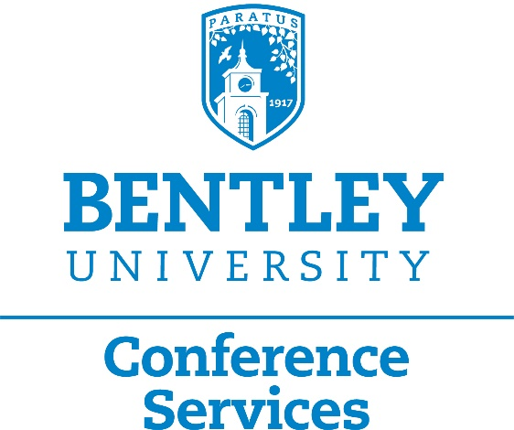

If you are interested in having an event with alcohol please be advised:

The following buildings have liquor licenses and do not require any additional permits: Dana Center, Lacava, and Student Center.

For all other locations (inside or out) a permit must be obtained from the city of Waltham. The fee is $250 and will be charged back to your cost center. Please fill out the permit request below and send back to Aamiot@bentley.edu. All applications must be received 45 days prior to event.

**Please Note: You will still need to work with Sodexo Catering for alcohol set up at your event.

LIQUOR PERMIT REQUEST FORM
Date Permit is Needed:
Location of Event:
Time of Bar Service:
Estimated Number of People:
Requestor:
Cost Code:
Signed:
Today’s Date:
Please return form to aamiot@bentley.edu
Please note you will still need to work with Sodexo Catering for alcohol set up at your event.
Form should be submitted a minimum of 30 days prior to the start of your event.

